Introduction
Video game development is a high-cost, high-risk industry. Studios can spend years and millions of dollars building a new game, only to find that it underperforms in the market. In an industry where the global market exceeds $180 billion annually, the ability to forecast units sold before launch could provide a major competitive advantage and better investment. Publishers and developers want to make informed decisions about which projects to greenlight, which platforms to target, and how to manage budgets efficiently.
The goal of this project was to build a predictive model using a real-world dataset and demonstrate the full machine learning workflow: exploratory data analysis, data preparation, model building, hyperparameter tuning, and evaluation. The core task was to understand the underlying drivers of the target variable and to evaluate which models were most effective at predicting it.
The business problem addressed in this project is predicting a game’s global sales performance before release, based on its known game characteristics. This potential predictive model could estimate sales potential using factors such as platform, genre, publisher, release year, and ESRB rating based on critic and user reviews. For example, certain genres may perform better on specific platforms or appeal to age demographics, while timing and platform trends could significantly influence overall demand.
A reliable predictive model enables more informed business decisions, reduces uncertainty, and creates opportunities to optimize operational or strategic processes. By formalizing patterns in the dataset and quantifying how different features contribute to predictions, organizations can decrease risk and improve planning. Even modest improvements in prediction accuracy can lead to meaningful operational or financial benefits.
This analysis aims to uncover patterns between the attributes and actual sales figures. By understanding which factors most strongly correlate with success, game publishers can better plan future releases and marketing strategies based on recent sales data. The target variable for the model will be the Global Sales feature. Beyond predictive accuracy, the model’s insights could help reduce financial risk and improve strategic planning. For example, smaller studios could use forecasts to decide whether to focus on niche genres with loyal audiences, while major publishers could use the model to prioritize high-potential titles for major investment. Ultimately, data-driven forecasting offers a practical way to align creative ambition with commercial reality in one of the world’s most competitive entertainment industries.

Stakeholders should understand that a well-calibrated predictive model provides insights into future game sales with:
- Clear, data-driven insights rather than assumptions
- The ability to estimate outcomes before committing resources
- A framework for monitoring performance over time
- A foundation for future automation or decision-support tools
Positioning this project to reduce uncertainty and support better forecasting makes the value proposition clear and actionable.
The dataset selected for this project is Video Game Sales with Ratings data from Rush Kirubi on Kaggle. This dataset contains 16,000 rows and has 16 columns with both numerical and categorical variables that required cleaning, exploration, and appropriate encoding before modeling. Columns include data for name of the game, game console, year of release, genre, publisher, North American sales, European sales, Japan sales, other sales, global sales, critic score, number of critics, user score, number of users, developer, and rating.
- Reference URL: https://www.kaggle.com/datasets/rush4ratio/video-game-sales-with-ratings

Summary of Milestones 1 - 3
Initial exploration focused on understanding the structure of the dataset, identifying patterns, and detecting potential issues that could affect modeling.
Key steps included:
- Inspecting data types and missing values
- Visualizing distributions to identify skewness or outliers
- Examining categorical variables using bar charts or frequency tables
EDA transformations included removing rows with NaNs, correcting how year data was displayed, and ensure that user scores were numeric for modeling.
Examples of EDA observations include Global Sales by Year of Release where we see the growth of video game units sold since 1980:
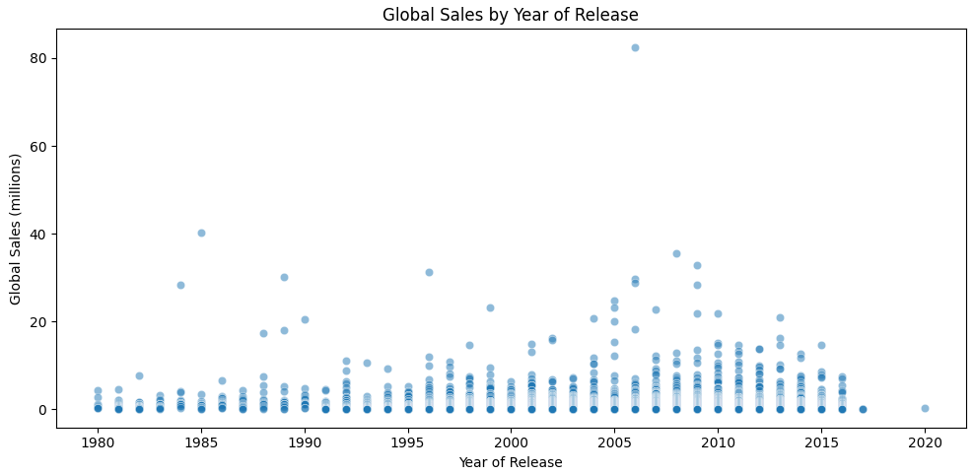

In addition, we get a view of global sales by genre to understand which types of video games see more sales:
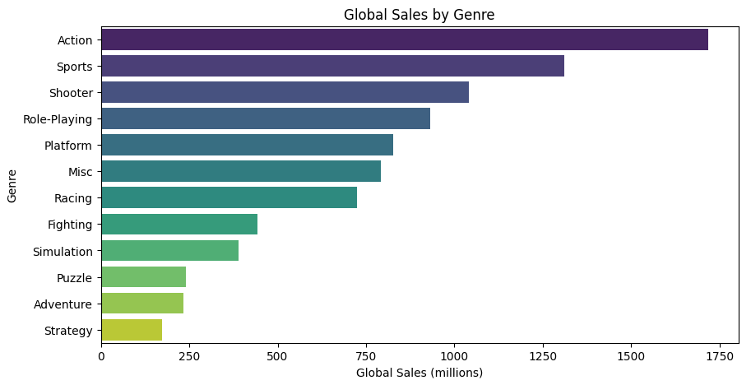

Additional data preparation included several transformations required to make the dataset usable for machine learning models:
- Removed rows that did not have the target of Global Sales
- Adjusted the Critic Score scale to match User Score
- Engineered new useful features for Total Score, Critic to User Score Difference, and decade determination
- Dealt with missing data by implementing imputation tactics for User Score, Critic Score, Publisher, and Rating
- Encoded categorical variables, such as Platform, Genre, Rating, and Publisher
- Split the data into training and test sets
- Created pipelines to ensure transformations were reproducible and applied only to training data
Pipelines were especially important because they encapsulate preprocessing and modeling steps in a single object, preventing data leakage and simplifying grid searches.
Multiple models were tested, including Linear Regression, Linear Regression with MinMax Scaler, and Random Forest. GridSearchCV was used to evaluate different hyperparameters and identify the best performing models. Pipelines help ensure that scaling, feature selection, and model fitting occurred inside the same workflow.
The models chosen were based on:
- Linear Regression is simple and a good baseline
- Linear Regression with MinMax Scale helps evaluate whether scaling improves performance
- Random Forest captures non-linear relationships and provides feature importance metrics
Linear models served as strong baselines. Random Forest models captured non-linear interactions and typically offered better predictive power on complex datasets. Selected metrics included:
- R2 helps determine the overall fit of the model to the data
- RMSE is useful for understanding typical error size
- MAE is less sensitive to outliers than RMSE and provides a robust view of prediction error
Overall, the evaluation metrics aligned with the project’s goals of prioritizing reliable, interpretable error measurement and choosing metrics suitable for the distribution of the target variable.

Conclusion
Several insights emerged from the modeling process:
- Linear models revealed straightforward relationships, helping to interpret the dataset’s main drivers
- Random Forest outperformed simpler models during cross-validation, suggesting non-linear interactions or complex patterns in the data
- Scaling, feature engineering, and proper preprocessing significantly influenced model performance, highlighting the importance of a structured workflow
The Random Forest model demonstrated better predictive ability on the test set compared to Linear Regression. The following is a summary of the results:
Model | R² | RMSE | MAE
Linear Regression | 0.186130 | 1.852369 | 0.557521
Linear Regression with MinMax Scaler | 0.186130 | 1.852369 | 0.557521
Random Forest (Best) | 0.199575 | 1.837006 | 0.458764

Based on the above metrics, we see that Random Forest has a slightly better R² score than Linear Regression, however they all explain only about 18% - 20% of the variation in sales. For RMSE, Random Forest is slightly better at avoiding mistakes. In MAE, we see that Random Forest is making smaller errors compared to Linear Regression. This suggests that Random Forest is recognizing non-linear patters that Linear Regression does not.
As for next steps, recommendations include:
- Continue using a tree-based model or other non-linear ensemble methods for highest performance
- Testing additional, non-linear models
- Collect additional data, if possible
- Implement feature importance monitoring to track model stability over time
- Consider simplifying features or removing low-value variables to streamline future training cycles
- Hyperparameter tuning with larger search spaces
- Engineering domain-specific features
- Investigating whether model performance changes over time
These opportunities can enhance model performance, robustness, and interpretability, making the system more reliable for long-term use. Comparing other non-linear options could help us find a better model for predictions. In addition, efficiency should be paid attention to as the workflows change and adapt.
Personally, I’ve enjoyed how this MS Data Science program continues to build on previously class learnings. This is my first time deep diving into model building, feature dimensionality, and tuning model hyperparameters. I was challenged a lot this term and am proud of the work I’ve been able to accomplish during this course. I found the exercises prepared me enough to implement learnings into the project milestones.
Milestone 1 helped me understand my level of comfort conducting EDA. Milestone 2 helped me think more about my approach, such as with imputation, engineering new features, and expanding on limited experience with creating dummy variables. Milestone 3 brought in the most challenges with applying newer material, such as:
- Understanding the value of each feature and how it can contribute to the model
- Determining which models to test for my specific dataset
- Creating pipelines, hyperparameter tuning, and grid searches
In conclusion, I learned a lot in trying to create and implement a model to help video game makers determine which type of game to create based on previous sales information. There is still opportunity to improve the modeling, but there is a solid foundation to build on.

